PAIN QUESTIONNAIRE FOR PATIENTS WITH

INJURY
(Please complete this form and bring it with you on your visit)

Last name:_______________ First Name:_______________ Title: Mr.___ Mrs.___ Dr.___

Appt Date:_______________ Primary Treating Physician:____________________________
(Please provide name and address of Doctor, of whom you want this report to be send to)

Age:_____ Dominant hand: R___ L___ Insurance Carrier: ___________________________

- Chief Complaints: (What is bothering you? What symptoms brought you to see the doctor? For example: severe lower back pain with pain going down to the right leg):

_____________________________________________________________________________

- HISTORY OF INJURY(at time of injury):

Job Title: __________________________ Employer: ___________________________

Date of Injury? ________ Mechanism of Injury (example: fall, Lifting, cumulative trauma)?______

Describe What Happened during Injury in detail: ___________________________________

_____________________________________________________________________________
_____________________________________________________________________________

Which are the Injured Body Parts? (check all appropriate box)
head___ Neck___ R. shoulder___ L. shoulder___ R. arm___ L. arm___ Upper back___ Mid back___ lower back___ R. Hip___ L Hip___ R. thigh___ L. thigh___ R. Knee___
L. Knee___ R. leg___ L leg___ R. ankle___ L. Ankle___ R. foot ___ L. foot___ OTHER_________________________________

Initial Injury: Your first symptoms? Pain___ Weakness___ Numbness___ Tingling____ swelling___ Others_____________________________________________________________

Did you report the injury immediately? Yes___ No___; If no, explain:____________________
Name of doctor/clinic where you were first seen_______________________ Date: _____________
Have you ever been hospitalized for this injury? Yes___, No___; hospital: ________________
What were your initial treatments: Medication____ X-ray ___ Therapy ____ Other:_______

____________________________________________________________________________

Employment status after injury:
Dates you were unable to work (as result of injury): From_____________ to ______________
Have you returned to work (where injury happened)? Yes___ No___ ; if yes: date:_________

- WORK & INJURY HISTORY (For the job you were working at the time of your injury)
Employment duration: Date of hire:_________ last day on this job?___________
Job Description: (Description of usual duties): _____________________________________________________________________________

_____________________________________________________________________________
Current work status:
Are you currently working? Yes___ No___ Employer: ___________ Job title: ___________

What is your current work restrictions: ____________________________________________
Previous work experience:
EMPLOYER | JOB TITLE | START DATE | END DATE | INJURY(exp.: neck, back, knee)
Past Injury( includes all injuries):
Date | Mechanism: (exp: car accident, fall, lifting, sports) | Body parts: (exp: neck, back, knee) | Compensation  $ | Treatment: (chiro, therapy,medication,surgery)

ADDITIONAL EXPLANATION FOR INJURY:_____________________________________

_____________________________________________________________________________

_____________________________________________________________________________

Studies to date(check all appropriate box):: X-ray date:_______ CT date:_______
EMG date:_________ Myelogram date:_______ MRI date:_____________ DISCOGRAM Date:___________ Other:__________________________________

Treatment so far (check all appropriate box):
Anti-inflammatory medications___ Pain medication___ Physical therapy___ Brace___ Chiropractor___ Acupuncture___ pool therapy ___ cervical traction___
Trigger point Injection ___ Epidural injection ___ Facet injection___ SI injection
Other:_______________________________________________________________________

4. PRESENT SYMPTOM: (PLEASE DO ONE BODY PART AT A TIME)
1st body part ( start with the most symptomatic body part):
(location) Where does it hurt now? (check 1st body part)
head___ Neck___ R. shoulder___ L. shoulder___ R. arm___ L. arm___ Upper back___ Mid back___ lower back___ R. Hip___ L Hip___ R. thigh___ L. thigh___ R. Knee___
L. Knee___ R. leg___ L leg___ R. ankle___ L. Ankle___ R. foot ___ L. foot___ OTHER_________________________________

(Association)Radiation of pain (example: pain radiate down to top of foot or numbness going down to finger tips): Where?_____________________ When?______________________

(Quality) Please characterize the discomfort:

Numbness___ Pins &needles___ ache___ burning ___Stabbing___ throbbing___

(Severity) Pain rating based on scale of 10 (0= no pain, 10=severe pain that you would rather die)?
(0_____ 1_____ 2_____ 3_____ 4_____ 5_____ 6_____ 7_____ 8_____ 9____ 10____)

(Timing) What time of the day is your discomfort worsen:
Morning___ later in the day___ mid. Of the night___ constant without relief___ Random___

(Factors aggravate or relief the symptoms): Better worse no different

Standing _____ _____ _____
Walking _____ _____ _____

Sitting _____ _____ _____

Bending forward _____ _____ _____
Bending backwards _____ _____ _____
Lying flat on back _____ _____ _____
Lying on my side with knees bent _____ _____ _____
With cough, sneeze, straining during bowl movements _____ _____ _____
Activities (vacuuming carpets, mowing lawn) _____ _____ _____
Exercise (jogging, aerobics) _____ _____ _____
Cold, damp weather _____ _____ _____
Heating pack _____ _____ _____

2nd body part:
(location) Where does it hurt now? (Please check 2nd most symptomatic body part below)
head___ Neck___ R. shoulder___ L. shoulder___ R. arm___ L. arm___ Upper back___ Mid back___ lower back___ R. Hip___ L Hip___ R. thigh___ L. thigh___ R. Knee___
L. Knee___ R. leg___ L leg___ R. ankle___ L. Ankle___ R. foot ___ L. foot___ OTHER_________________________________

(Association)Radiation of pain (example: pain radiate down to top of foot or numbness going down to finger tips): Where?_____________________ When?______________________

(Quality) Please characterize the discomfort:

Numbness___ Pins &needles___ ache___ burning ___Stabbing___ throbbing___

(Severity) Pain rating based on scale of 10 (0= no pain, 10=severe pain that you would rather die)?
(0_____ 1_____ 2_____ 3_____ 4_____ 5_____ 6_____ 7_____ 8_____ 9____ 10____)

(Timing) What time of the day is your discomfort worsen:
Morning___ later in the day___ mid. Of the night___ constant without relief___ Random___

(Factors aggravate or relief the symptoms): Better worse no different

Standing _____ _____ _____
Walking _____ _____ _____

Sitting _____ _____ _____

Bending forward _____ _____ _____
Bending backwards _____ _____ _____
Lying flat on back _____ _____ _____
Lying on my side with knees bent _____ _____ _____
With cough, sneeze, straining during bowl movements _____ _____ _____
Activities (vacuuming carpets, mowing lawn) _____ _____ _____
Exercise (jogging, aerobics) _____ _____ _____
Cold, damp weather _____ _____ _____
Heating pack _____ _____ _____

3rd body part:
(location) Where does it hurt now? (Please check the 3rd body part below)
head___ Neck___ R. shoulder___ L. shoulder___ R. arm___ L. arm___ Upper back___ Mid back___ lower back___ R. Hip___ L Hip___ R. thigh___ L. thigh___ R. Knee___
L. Knee___ R. leg___ L leg___ R. ankle___ L. Ankle___ R. foot ___ L. foot___ OTHER_________________________________

(Association)Radiation of pain (example: pain radiate down to top of foot or numbness going down to finger tips): Where?_____________________ When?______________________

(Quality) Please characterize the discomfort:

Numbness___ Pins &needles___ ache___ burning ___Stabbing___ throbbing___

(Severity) Pain rating based on scale of 10 (0= no pain, 10=severe pain that you would rather die)?
(0_____ 1_____ 2_____ 3_____ 4_____ 5_____ 6_____ 7_____ 8_____ 9____ 10____)

(Timing) What time of the day is your discomfort worsen:
Morning___ later in the day___ mid. Of the night___ constant without relief___ Random___

(Factors aggravate or relief the symptoms): Better worse no different

Standing _____ _____ _____
Walking _____ _____ _____

Sitting _____ _____ _____

Bending forward _____ _____ _____
Bending backwards _____ _____ _____
Lying flat on back _____ _____ _____
Lying on my side with knees bent _____ _____ _____
With cough, sneeze, straining during bowl movements _____ _____ _____
Activities (vacuuming carpets, mowing lawn) _____ _____ _____
Exercise (jogging, aerobics) _____ _____ _____
Cold, damp weather _____ _____ _____
Heating pack _____ _____ _____

Self-assessment of current condition, (without interruption)-
How long are you able to walk? _______ How long are you able to stand? _________
How long are you able to sit?____________
Can you continue current occupation? _______________________________

If you had prior neck or back surgeries please complete this box:
Date of surg. | Surgeon | Reason for surgery | Type of procedures | Did symptoms improve post-op?

Past Medical history (example: diabetes, high blood pressure, Panic disorder)

Past Surgical History (other than neck or back surgery)
Date | Surgeon | City | Diagnosis | procedures

Allergies to medication:
Name of medication | Reaction after taken medication

Medication:
Name of medication | Dosage (mg) | # of times per day
Social History:
Marital status?: ___single ___married ___Divorced
How much do you smoke? :___ none, ___yes (# of pack per day_____, # of years_________)
How much do you drink? :______________________________________________________
Are you currently employeed? ___yes, ___No.
How long have you not been working? (_____)
Is there attorney or litigation involved or in your case? ___yes, ___no.

Family History:
Father ___alive ___deceased Cause of death _____________________
Mother ___alive ___deceased Cause of death______________________
Any other disease in the family (exp: bleeding disease,diabetes): ______________________

Review of Systems: (Check all appropriate, leave line blank if does not apply to you)
1. Neurological:
Do you have difficulty with walking, falling?___ Do you experience clumsiness with your hands? Dropping objects?___ Do you have difficulty control your bowel or bladder?______

2. Constitutional:
Do you have recent unintentional weight loss?__ Do you have recent fever, chill, night sweats?___

Review of Systems continue: (check all appropriate, leave line blank if does not apply to you )

- Eyes:
Glaucoma___ eye infection___ nearside___ farside___ blurring___ cataract___

- Ear, Nose, throat, mouth:
Discharge___ ringing in ear___ nose bleed___ dizziness___ infection___

- Cardiovascular:
Chest pain___ high blood pressure___ heart murmur___ irregular pulse___

- Respiratory:

Asthma___ bronchitis___ pneumonia___ TB___ chronic cough___

- Gastrointestinal:
Nausea___ vomiting___ diarrhea___ abdominal pain___ liver problem___
Coughing up blood___ hemorrhoids___

- Genitourinary:
Painful urination___ kidney stone___ blood in urine___ urinary infection___

- Musculoskeletal:
Prior fractures___ weakness___ joint swelling/pain___ arthritis___ gout___

- Skin:
Breast lump___ rashes___ Scar___ nipple discharge___ skin disease___

- Psychiatric:
Depression___ schizophrenia___ bipolar___ anxiety___ headache___

- Endocrine:
Diabetes___ heat or cold intolerance___ thyroid disease___ goiter___

- Blood:
Anemia___ bleeding tendencies___ easy bruising___ blood transfusions___low platelet___

- Allergy:
Hives___ itching___

- Genitoreproductives:
Venereal disease___ discharge___ hernias___menopause___difficulty intercourse___

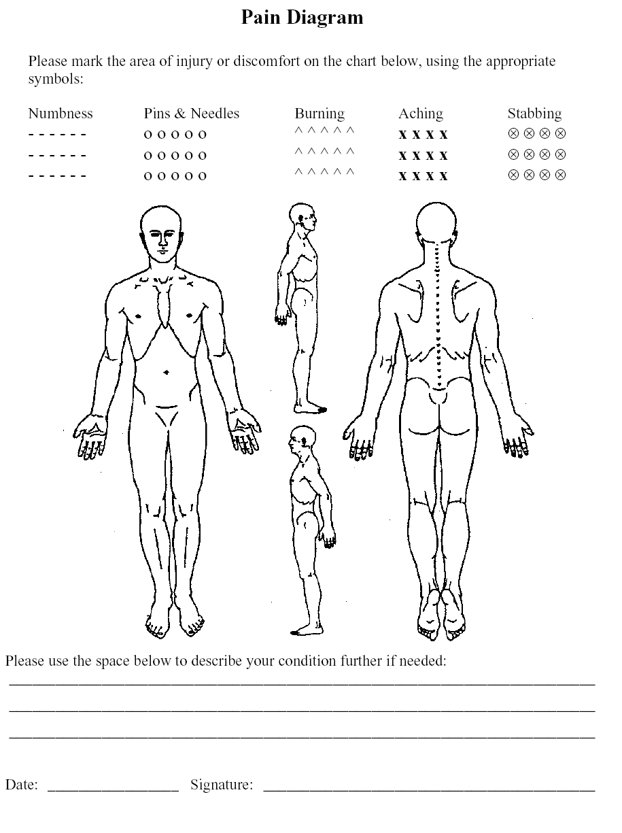
ACTIVITIES OF DAILY LIVING COMMONLY
MEASURED IN ACTIVITIES OF DAILY LIVING (ADL)*
(Based on Pg. 4 Guides to the Evaluation of Permanent Impairment, 5th Edition)

Name of Applicant: __________________________________ Date:_________________

APPLICANT HAS DIFFICULTY WITH:
(Mark with an “X” below and explain where indicated)
 | CATEGORY OF ACTIVITY | ACTIVITY | Without Difficulty | With Some Difficulty | With Much Difficulty | Mostly Unable to Do
1. | Self-care, personal hygiene  (Urinating, defecating, brushing teeth, combing hair, bathing, dressing oneself, eating) | Take a shower
 |  | Take a bath
 |  | Wash & dry body
 |  | Wash & dry face
 |  | Turn on/off faucets
 |  | Brush teeth
 |  | Get on/off toilet
 |  | Comb/brush hair
 |  | Dress self
 |  | Put on/off shoes/socks
 |  | Open carton of milk
 |  | Open a jar
 |  | Lift glass/cup to mouth
 |  | Make a meal
 |  | Lift fork/spoon to mouth
 |  | Describe other: (bladder and bowel function difficulties: incontinence, retention, constipation?)
2. | Physical activity  (Standing, sitting, reclining, walking, climbing stairs) | Stand
 |  | Sit
 |  | Recline
 |  | Rise from a chair
 |  | Get in/out of bed
 |  | Climb flight of 10 stairs
 |  | Work outdoors
 |  | Light housework
 |  | Shop/do errands
 |  | Carry groceries
 |  | Lift 5 lbs.
 |  | Lift 10 lbs.
 |  | Lift 20 lbs.
 |  | Lift 30 lbs.
 |  | Walk
 |  | Care for children or parents
 |  | Engage in hobbies (music or crafts, etc.) Indicate hobby:
 |  | Describe other: (eating/chewing difficulty: TMJ?)
APPLICANT HAS DIFFICULTY WITH:
(Mark with an “X” below and explain where indicated)
 | CATEGORY OF ACTIVITY | ACTIVITY | Without Difficulty | With Some Difficulty | With Much Difficulty | Mostly Unable to Do
3. | Communication  (Writing, typing, seeing, hearing, speaking) | Write a note
 |  | Type a message on a computer/typewriter
 |  | See a television screen
 |  | Use a telephone
 |  | Speak clearly
 |  | Hear clearly
 |  | Describe other:
4. | Nonspecified hand activities  (Grasping, lifting, tactile, discrimina-tion) | Pick up small items
 |  | Turn a knob on a door
 |  | Write with a pen/pencil
 |  | Steer wheel of car
 |  | Describe other:
5. | Sensory function  (Hearing, seeing, tactile feeling, tasting, smelling) | Feel what you touch
 |  | Taste what you eat
 |  | Smell what you eat
 |  | Describe other:
6. | Travel  (Riding, driving, flying) | Get in/out of a car
 |  | Drive a car
 |  | Ride in a car
 |  | Fly in a plane
 |  | Ride a bicycle
 |  | Describe other:
7. | Sexual function  (Orgasm, ejacula-tion, lubrication, erection) | Engage in sexual activity
 |  | Describe specific difficulty: (Orgasm, ejaculation, lubrication, erection?)
8. | Sleep  (Restful sleep, nocturnal sleep pattern) | Get to sleep
 |  | Sleep through the night
 |  | Have restful sleep
 |  | Feel refreshed after sleep
 |  | Describe specific difficulty: (teeth grinding at night, excessive daytime fatigue, irritability, etc.)

